Project Design Phase Problem – Solution Fit

Date | 06/07/26
Team ID | SWTID-2026-9649
Project Name | Sports Hall Booking System by Service Portal(ServiceNow)
Maximum Marks | 2 Marks

Problem–Solution Fit Overview
The Sports Hall Booking System addresses the difficulties associated with manual and fragmented sports facility booking processes. The solution uses the ServiceNow Service Portal to provide a centralized booking experience while supporting administrators through automation and organized booking records.
Key Problems Identified
Difficulty Checking Availability:
Users may find it difficult to know whether a sports hall is available for their preferred date and time.
Booking Conflicts:
Manual booking processes can result in overlapping reservations and scheduling conflicts.
Manual Booking Management:
Administrators may spend significant time monitoring, updating, and managing multiple booking records.
Delayed Booking Updates:
Users may not receive booking confirmations, reminders, or status updates efficiently.
Cancellation and Refund Handling:
Manual calculation of cancellation charges and refund amounts can increase administrative effort.
Proposed Solution
The proposed Sports Hall Booking System using ServiceNow provides a centralized digital solution that includes:
Sports Zone Service Portal for user interaction
Centralized sports hall and booking records
Booking-related validation and business logic
Business Rules for cancellation and refund calculations
Flow Designer for process automation
Scheduled Jobs for automated activities
Booking-related notifications and reminders
Reports and dashboards for information visibility
Problem–Solution Fit
Difficulty checking availability
→ Centralized sports hall and booking information
→ Improved access to booking information
Booking conflicts
→ Booking validation and centralized records
→ Better reservation management
Manual administrative work
→ Business Rules, Flow Designer, and Scheduled Jobs
→ Reduced repetitive administrative effort
Delayed booking updates
→ Automated notifications and reminders
→ Improved communication with users
Manual cancellation calculations
→ Automated cancellation charge and refund logic
→ More consistent cancellation processing
Value Proposition
The Sports Hall Booking System provides a centralized, organized, and automated approach to sports facility booking. By combining user interaction, booking management, business logic, automation, notifications, and reporting within ServiceNow, the solution improves the overall booking process for both users and administrators.

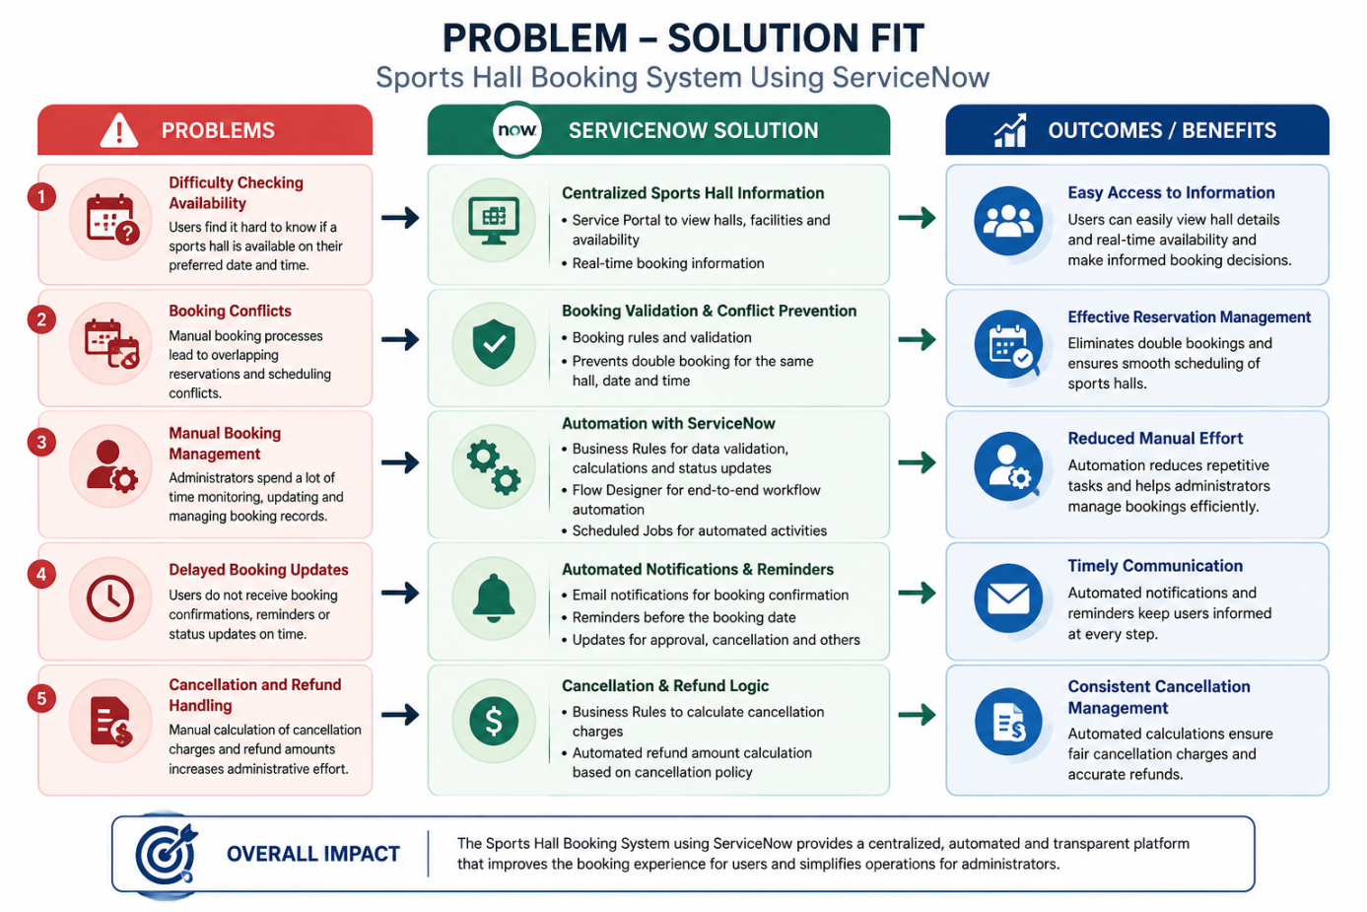

Conclusion
The proposed solution directly addresses the identified booking and management challenges. The alignment between user problems and implemented ServiceNow capabilities demonstrates a strong Problem–Solution Fit for the project.

